
Project Report



Submitted by: Group 04

Name | ID
Muziba Mahmuda Mithy | 2022-1-60-011

Submitted to:
Name: Ahmed Adnan
Designation: Lecturer
Department of CSE, EWU

What is solid principles?
The five object-oriented design guidelines known as SOLID principles aid programmers in creating software that is scalable, flexible, clean, and maintainable.
They provide guidelines for the design of classes and objects, so code is:
- simpler to comprehend
- simpler to change
- less likely to make mistakes
SOLID stands for:
- S — Single Responsibility Principle
- O — Open/Closed Principle
- L — Liskov Substitution Principle
- I — Interface Segregation Principle
- D — Dependency Inversion Principle
Applying solid principles on our University Management System
Course Management Part
For Courses.java:
Previous Code:
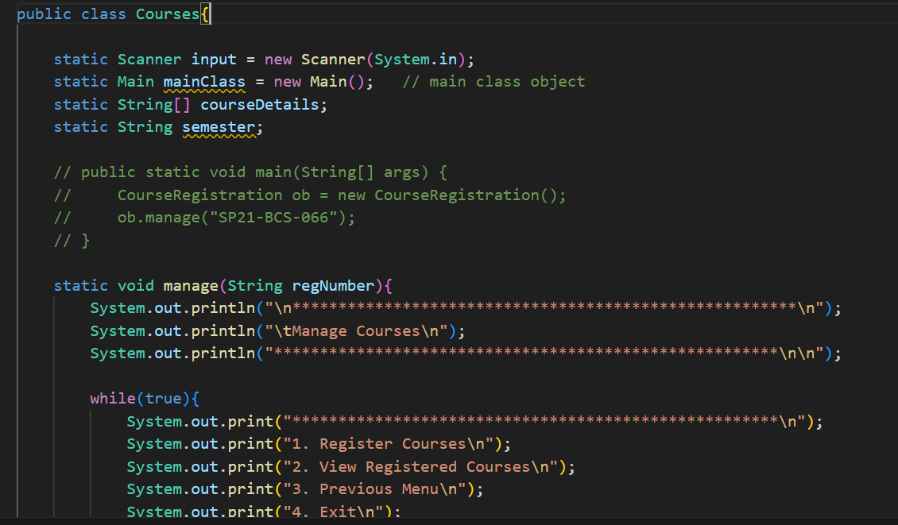
……………………………………………………………………………………….
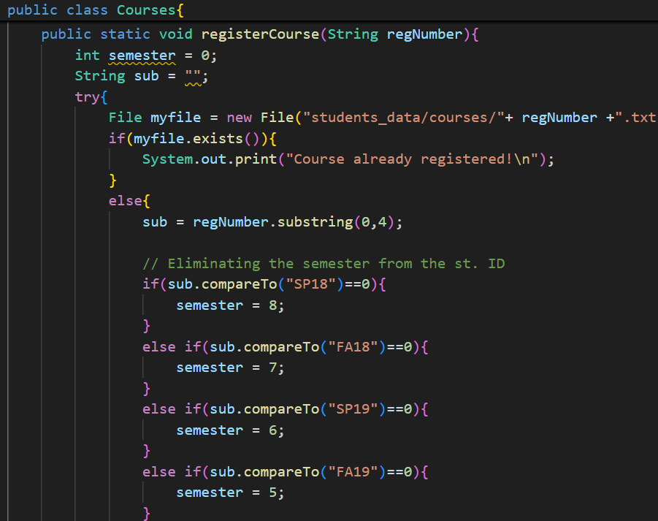
……………………………………………………………………………………….
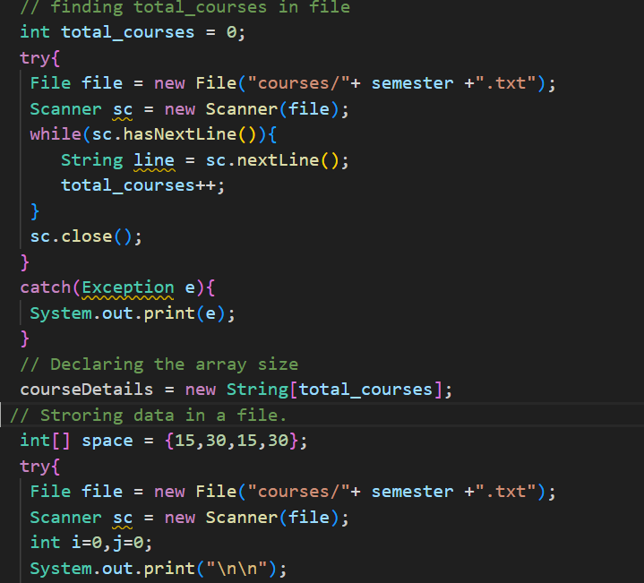
………………………………………………………………………………
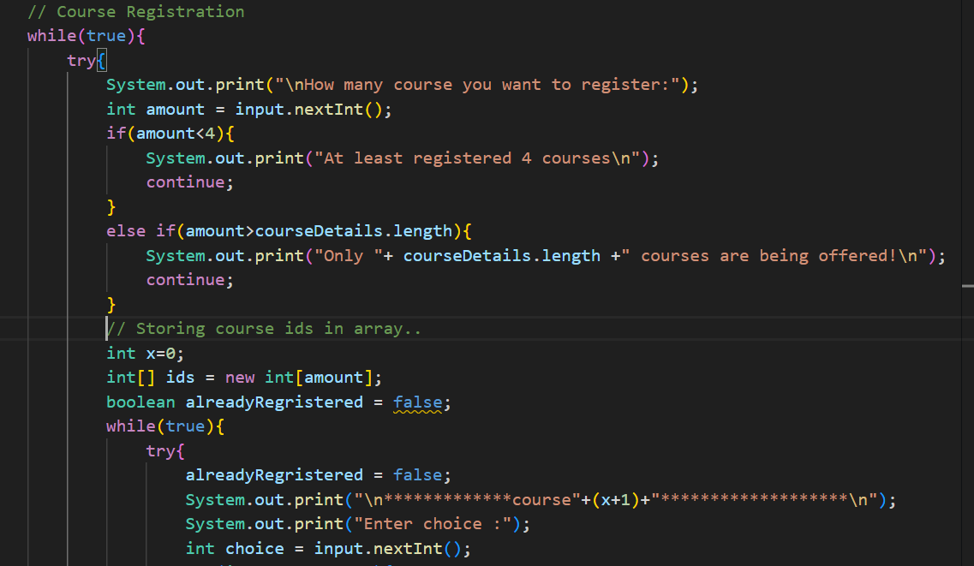
……………………………………………………………………………….
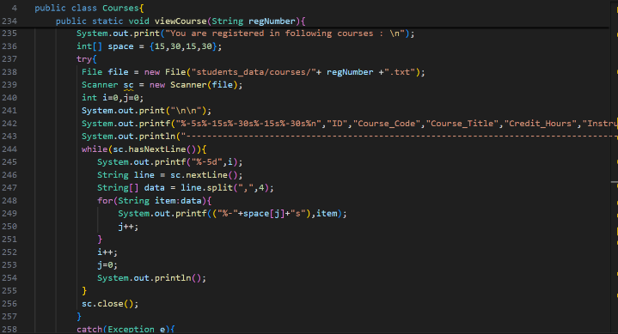
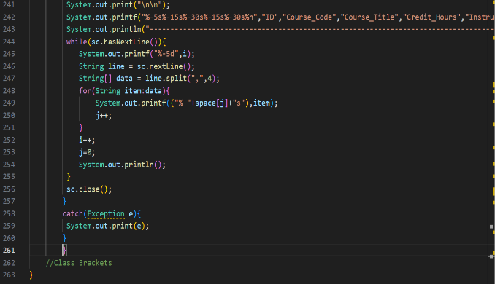

Applying Solid Principle
Table for applied principle:
Single responsibility principle | Applied
Open Closed principle | Not applied
Liscov substitution principle | Not applied
Interface segregation principle | Not applied
Dependency inversion principle | Not applied

Single Responsibility Principle
In this part single responsibility principle is violated. A class should have only one responsibility. But we can see in the previous code that Courses class is handling all the responsibility. That’s why we have created different classes to handle different work.
After applying solid principle:
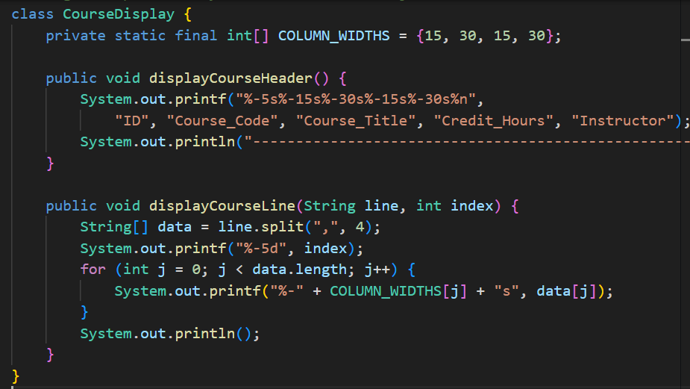
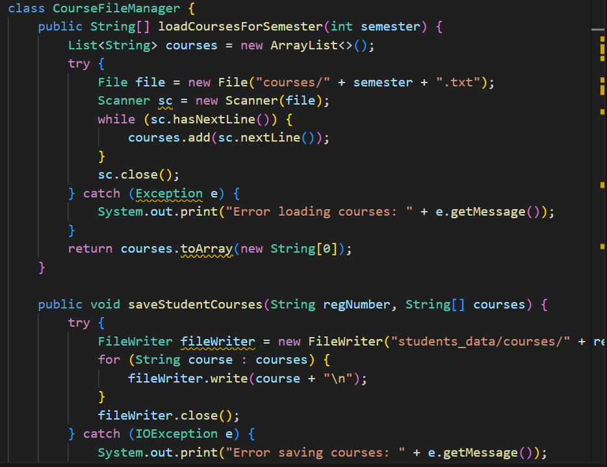
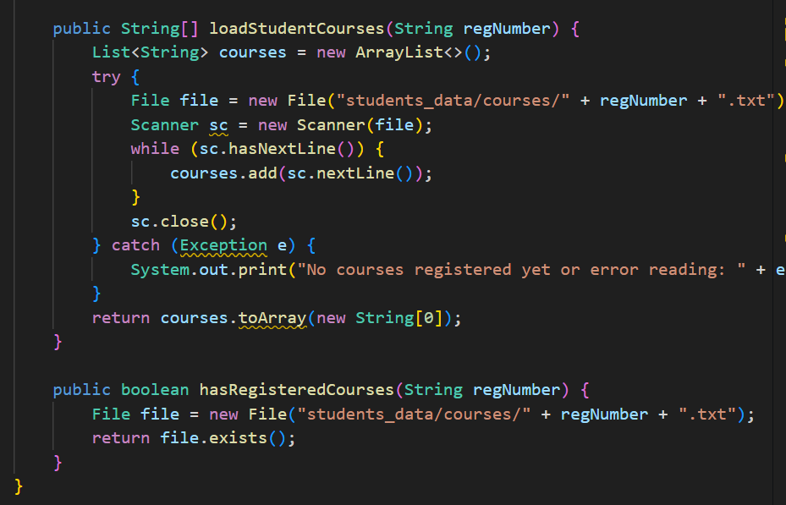
…………………………………………………………………………
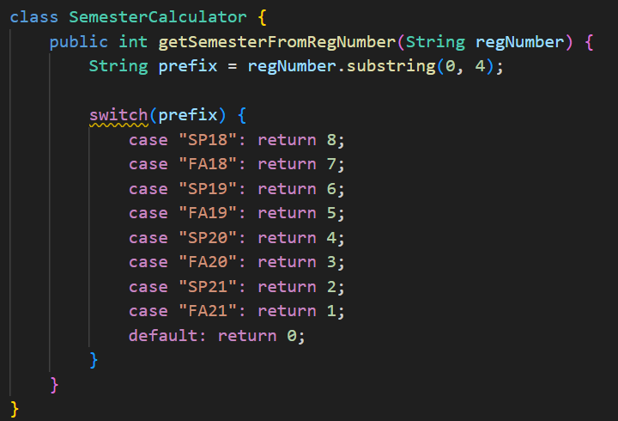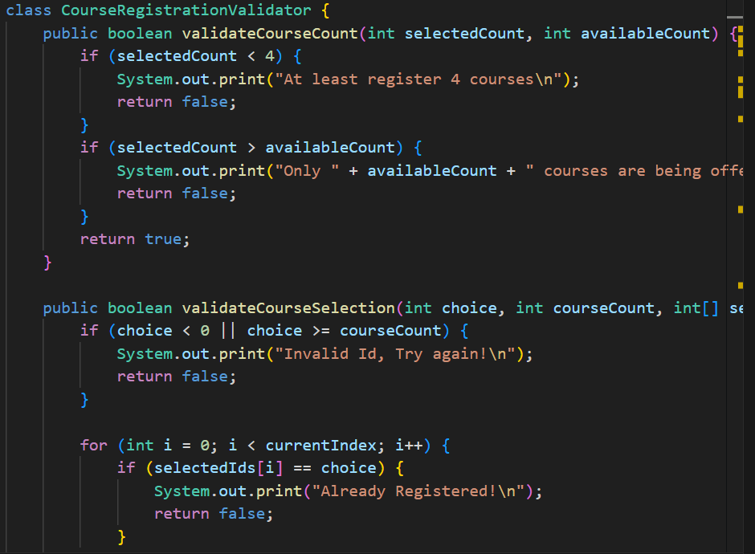
………………………………………………………………….
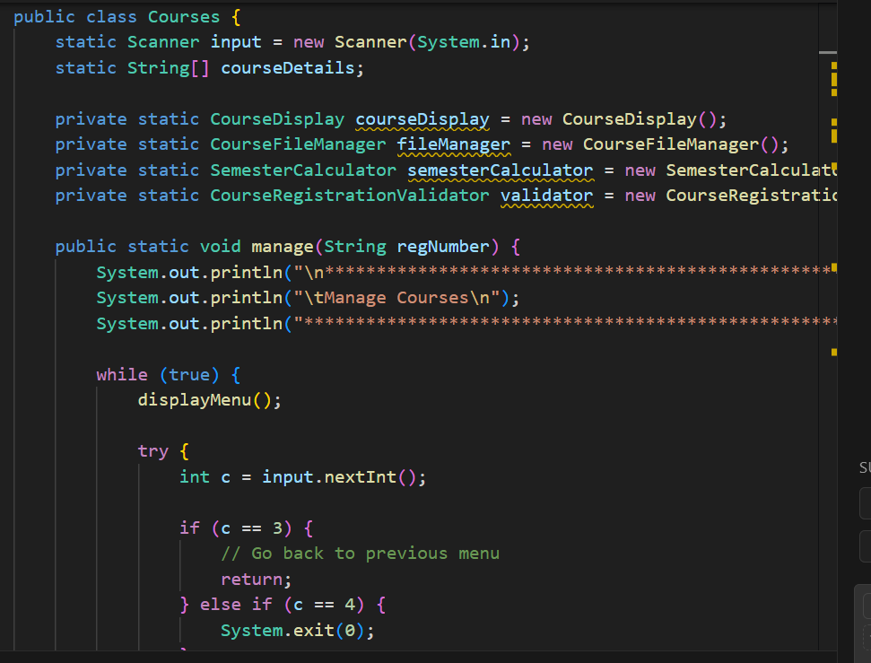
…………………………………………………………………
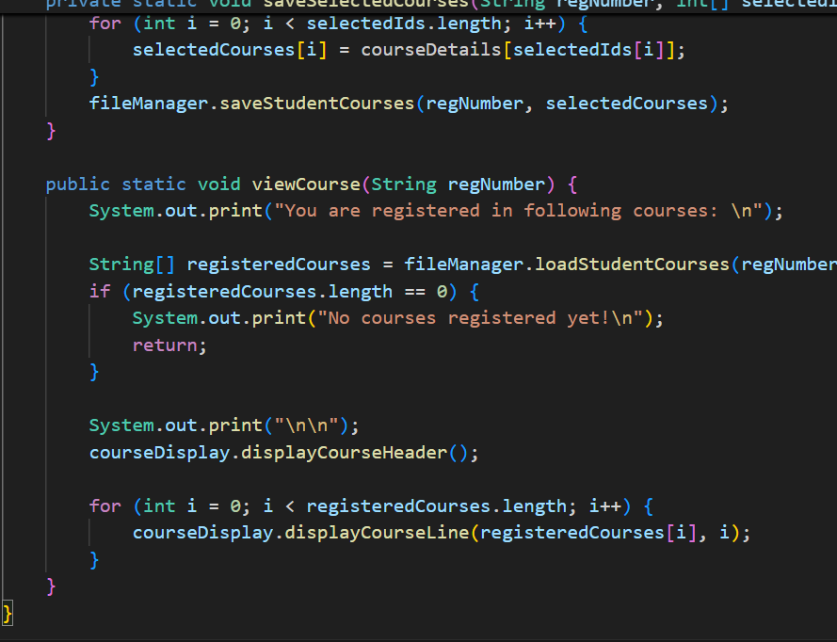
For CourseRegistration.java:
Previous Code :
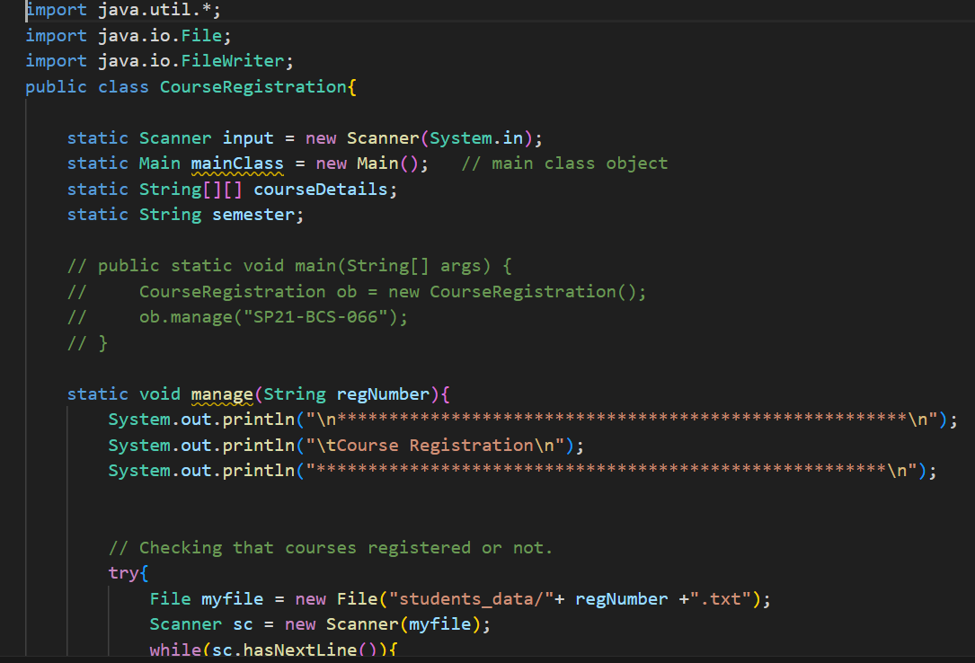
……………………………………………………………………..
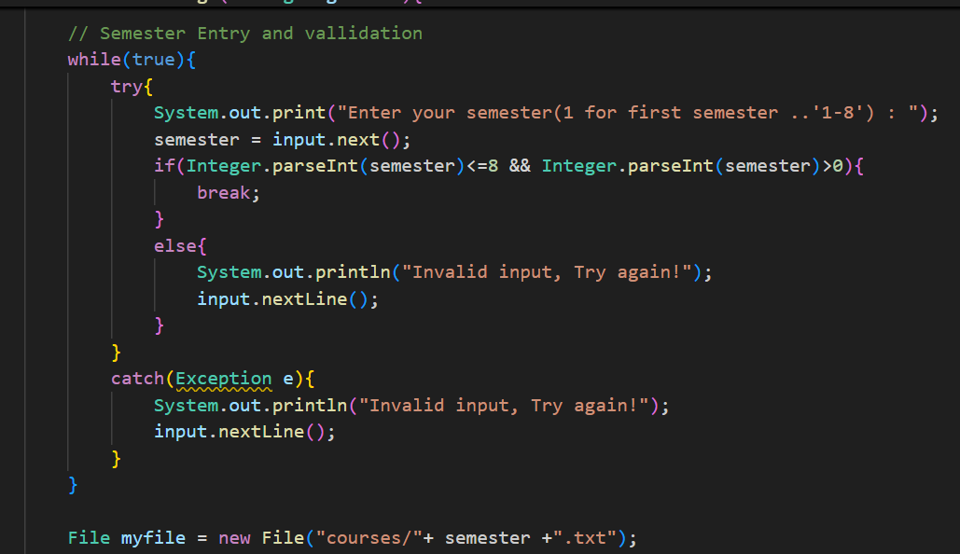
………………………………………………………………………
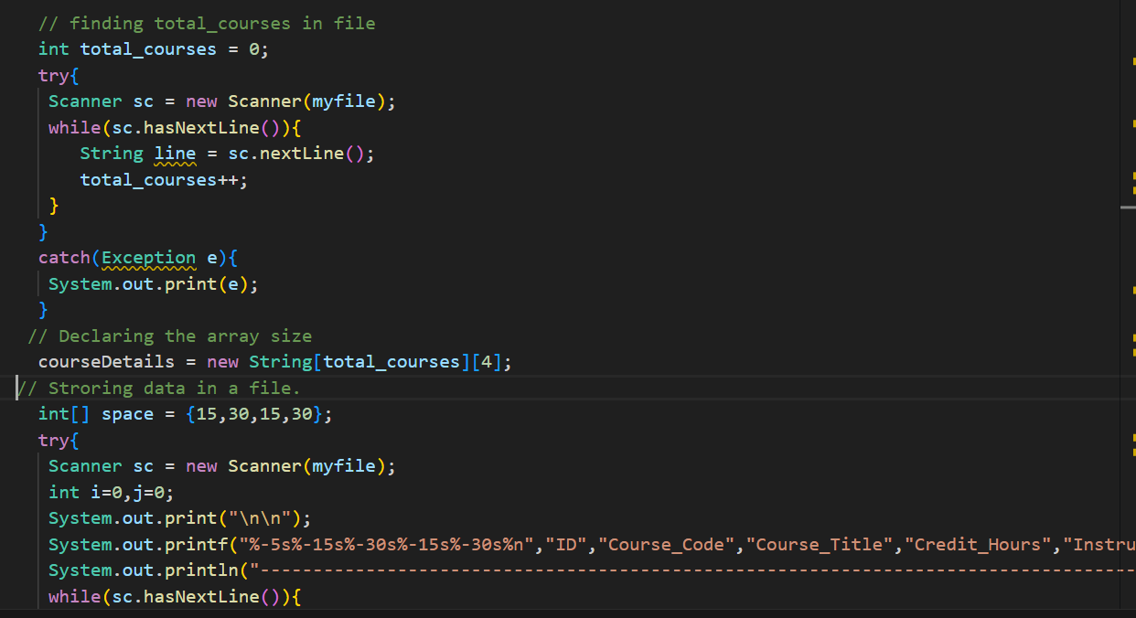
…………………………………………………………….
Applying Solid Principle
Table for applied principle:
Single responsibility principle | Applied
Open Closed principle | Not applied
Liscov substitution principle | Not applied
Interface segregation principle | Not applied
Dependency inversion principle | Not applied

Single Responsibility Principle
In this section, single responsibility principle is violated. A class should have only one responsibility. But we can see in the previous code that CourseRegistration class is handling all the responsibility. That’s why we have created different classes to handle different work.
After applying solid principle:
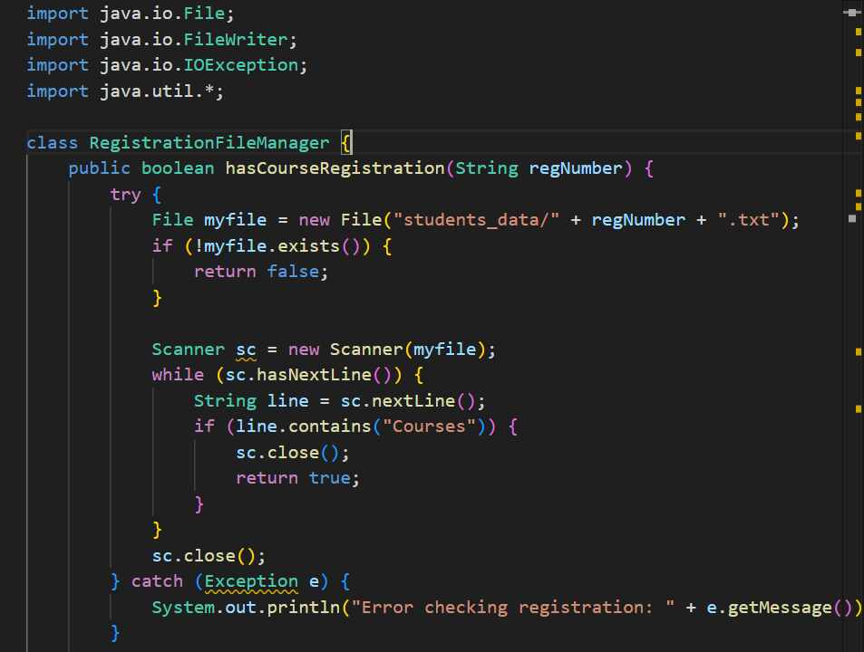
………………………………………………………………………
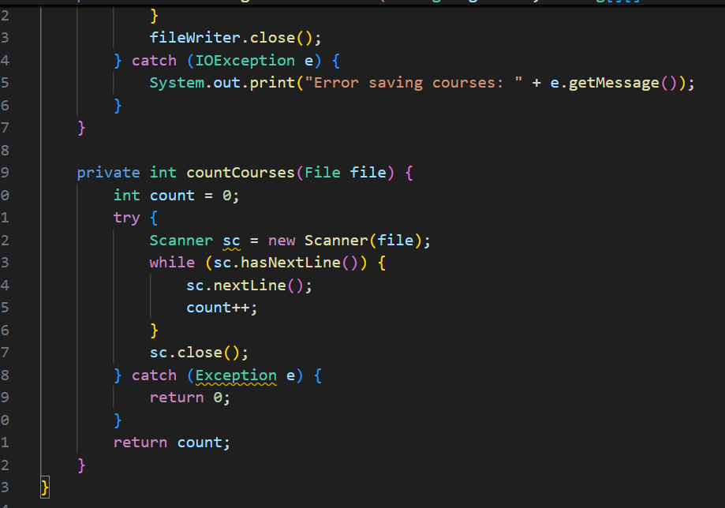
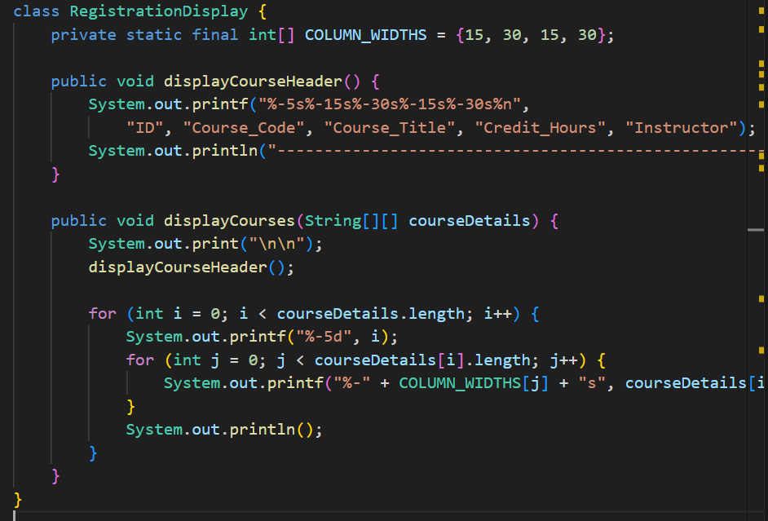
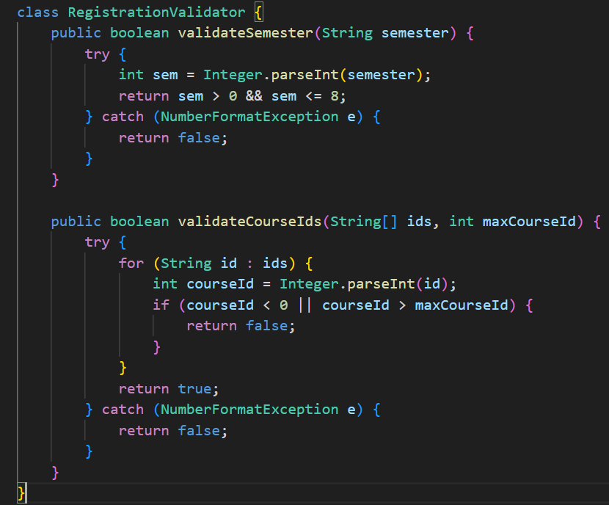
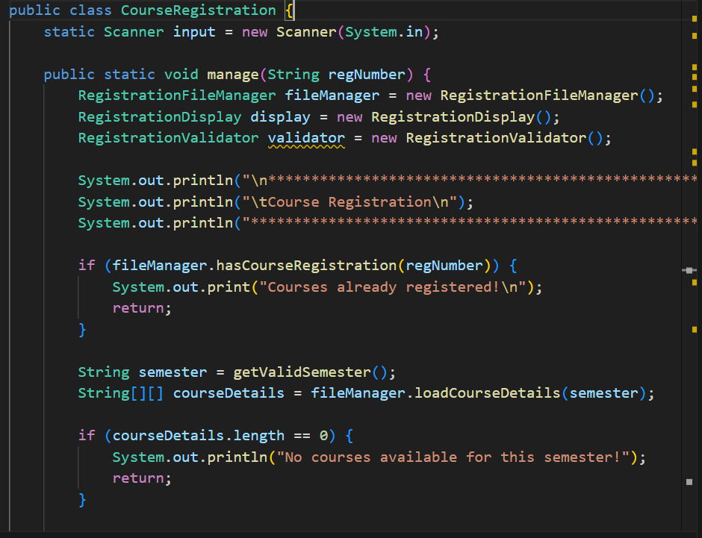
…………………………………………………………………
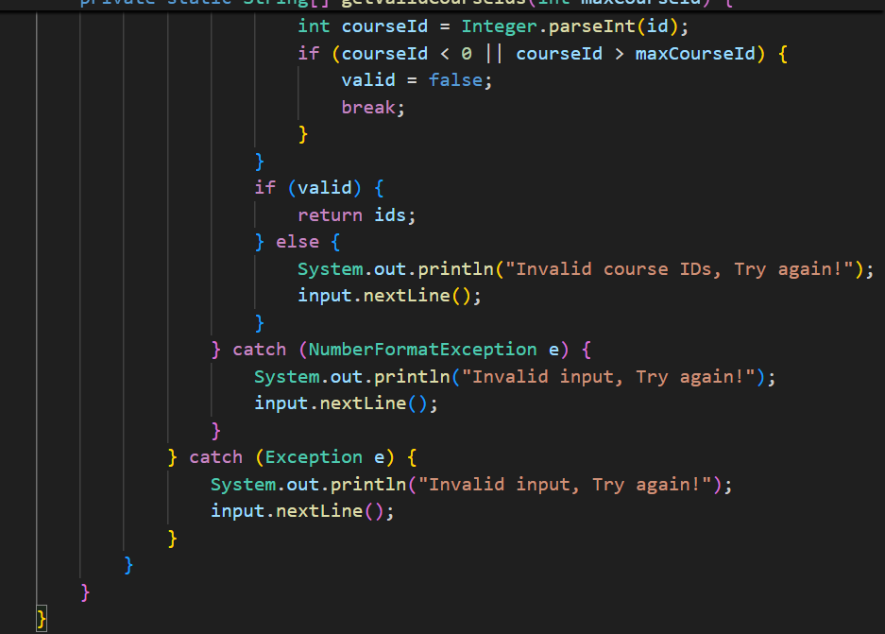

Previous output:
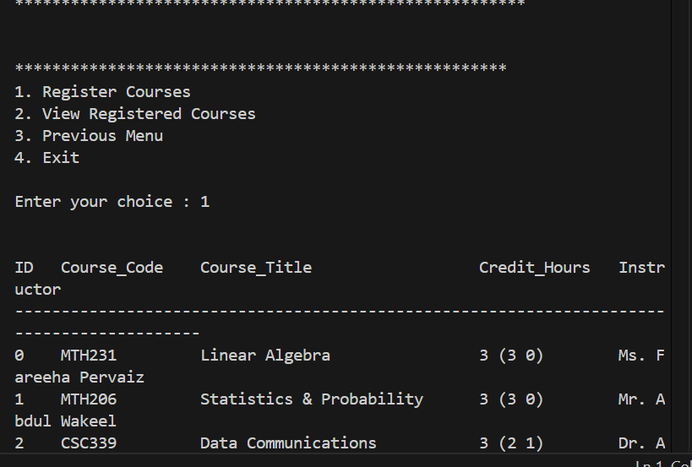
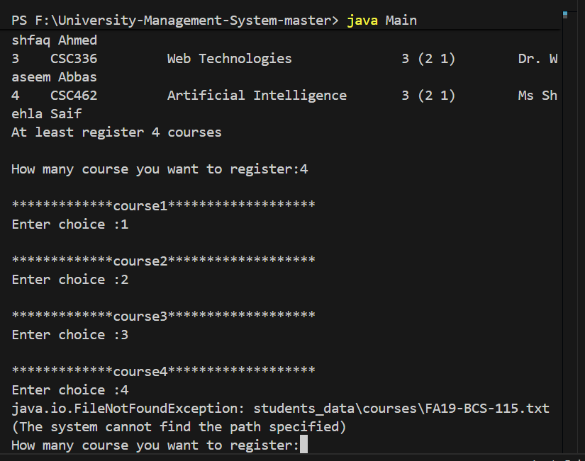
After applying solid principle output:
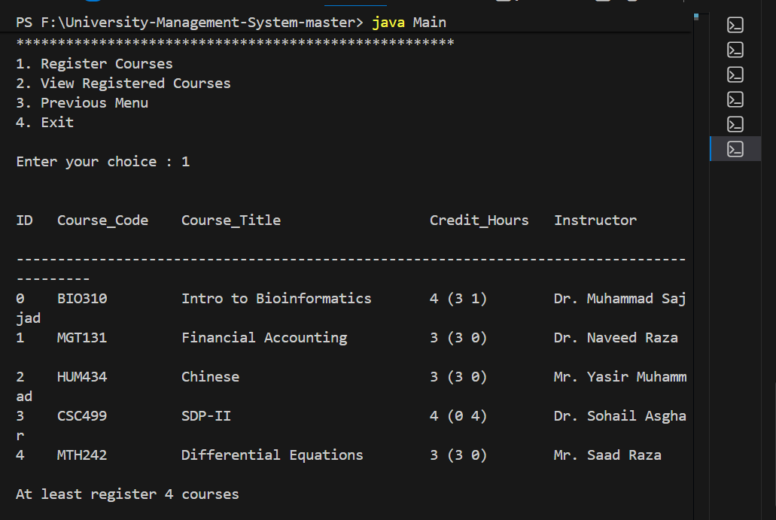
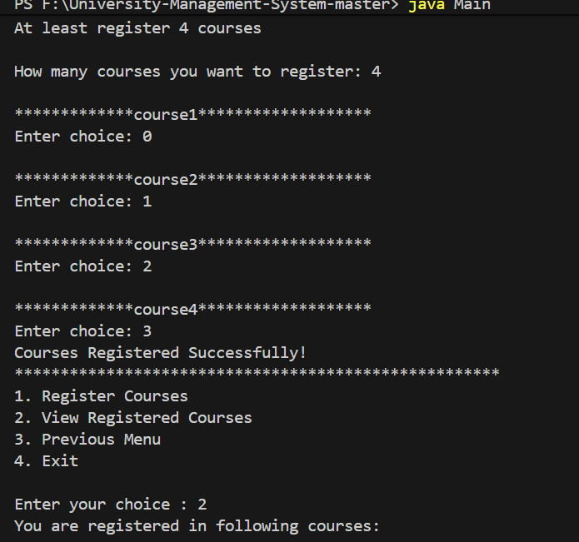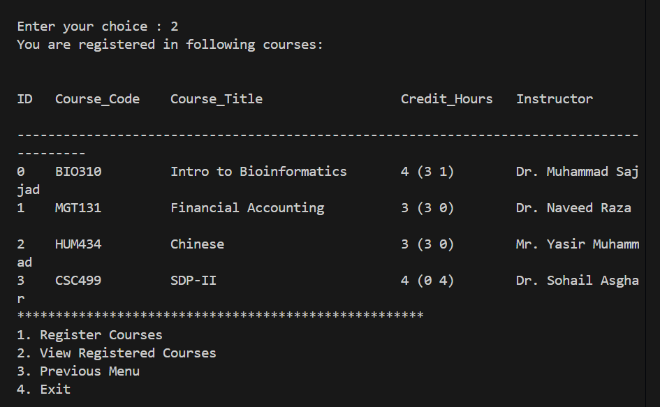

Refactoring code smells
For Courses.java:
1. Inappropriate Naming
Example: ( int c )
Previous Code:
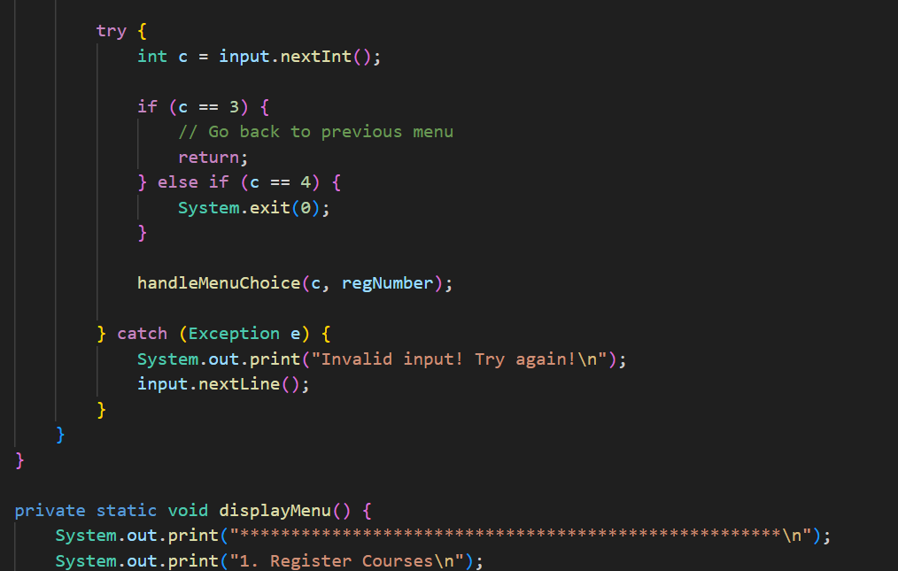
…………………………………………………………………………………………..
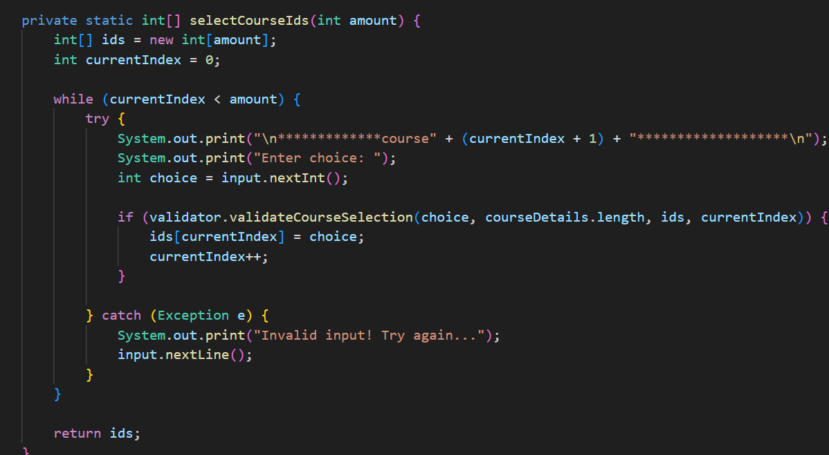
……………………………………………………………………………………………
Refactoring:
Better names: ( menuChoice, courseCount )
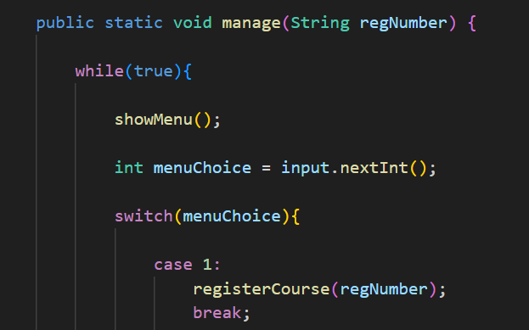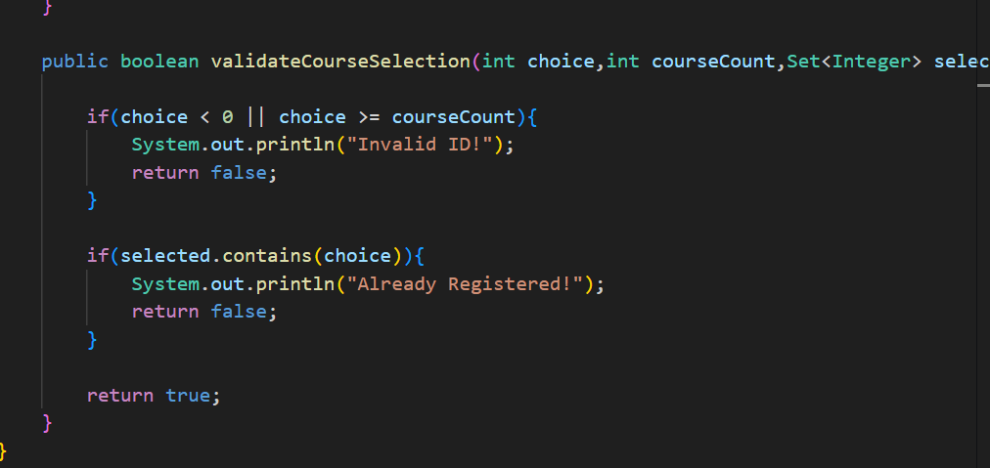
……………………………………………………………………………………
2. Long Method
Example methods: ( registerCourse(), registerSelectedCourses(), selectCourseIds() )
They do multiple things:
- validation
- user interaction
- saving data
Previous code:
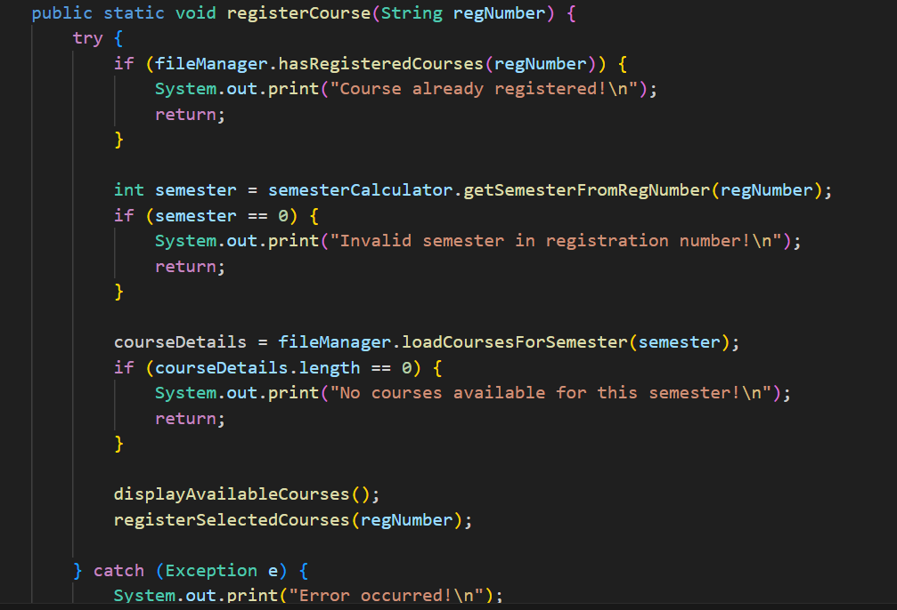
………………………………………………………………………………………………
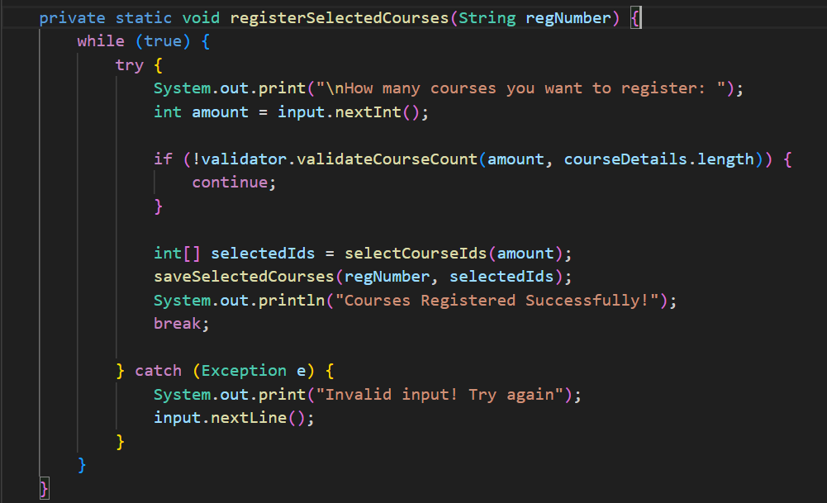
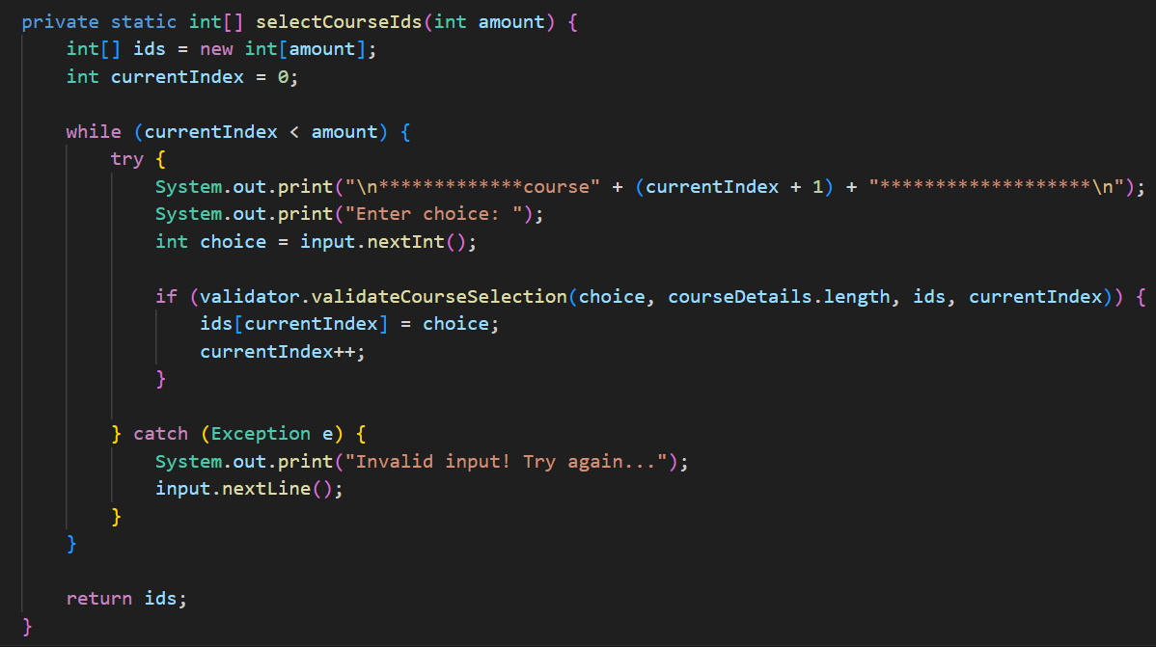…………………………………………………………………………………………………

Refactoring:
Remedy Used: Extract Method
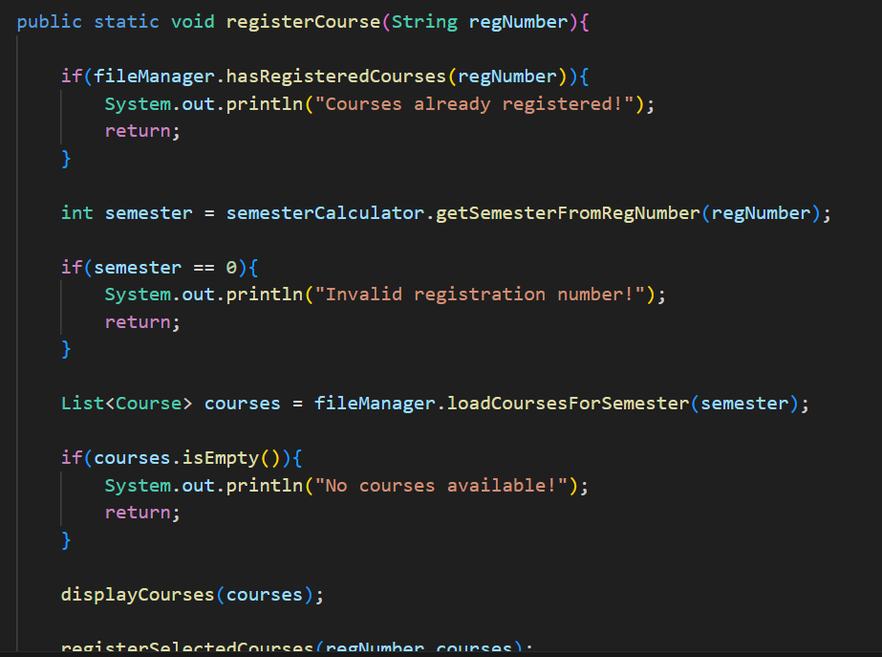
………………………………………………………………………………………………..
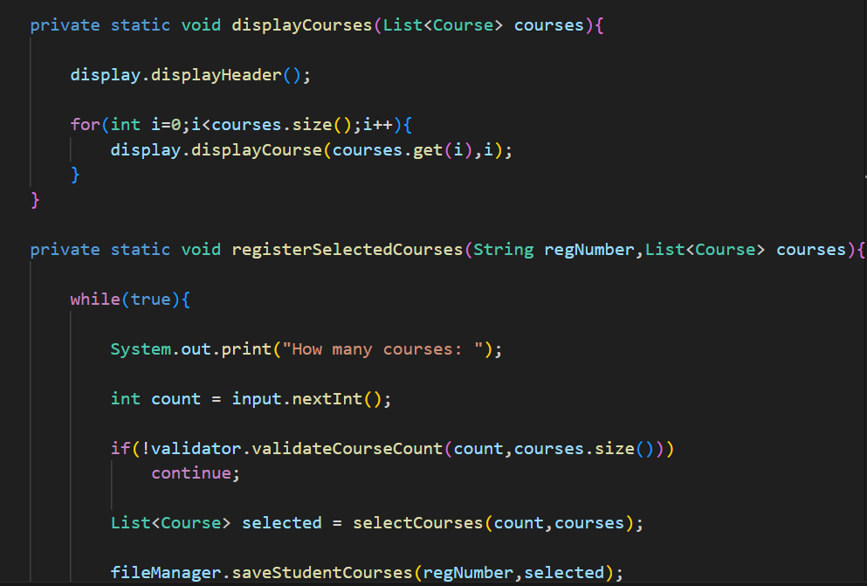
……………………………………………………………………………………………….
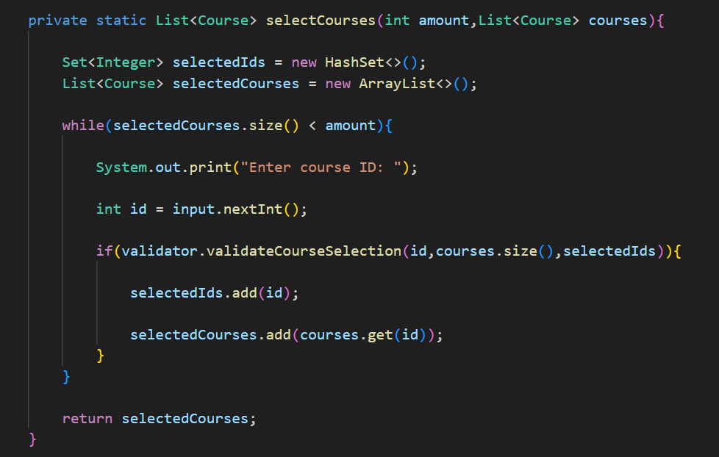
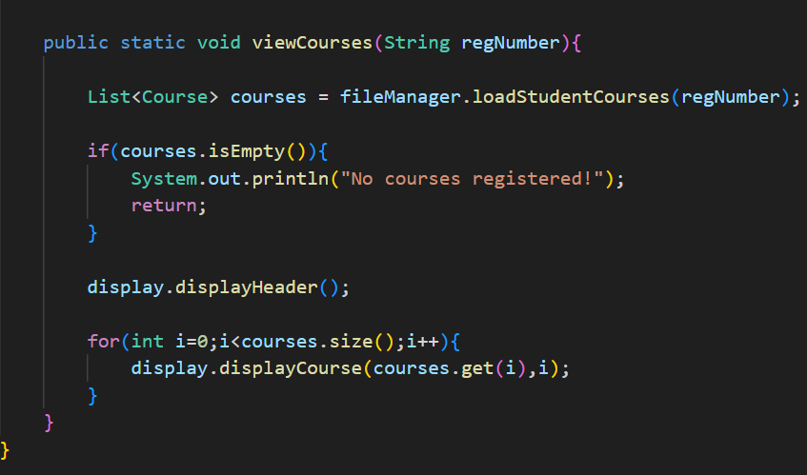

3. Switch Statements
Previous Code:
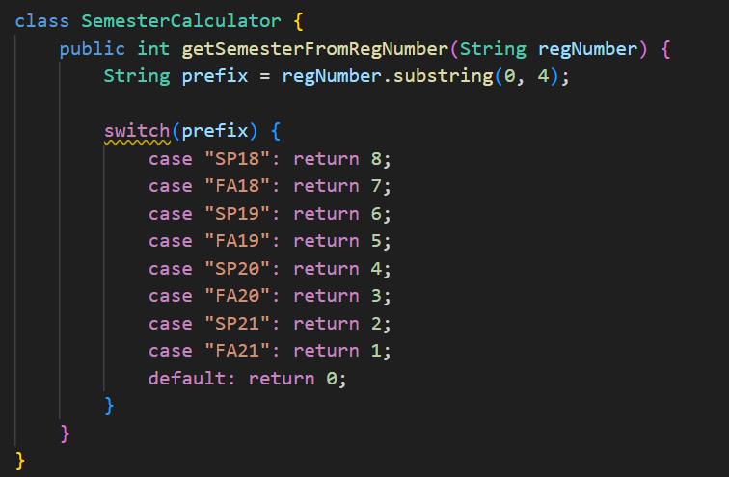

Refactoring:
Remedy Used: Replace Type Code with Polymorphism (via Map instead of switch) conceptually replacing switch logic.
Instead of using a large switch statement to determine semester from registration number, we have replaced it with a Map.

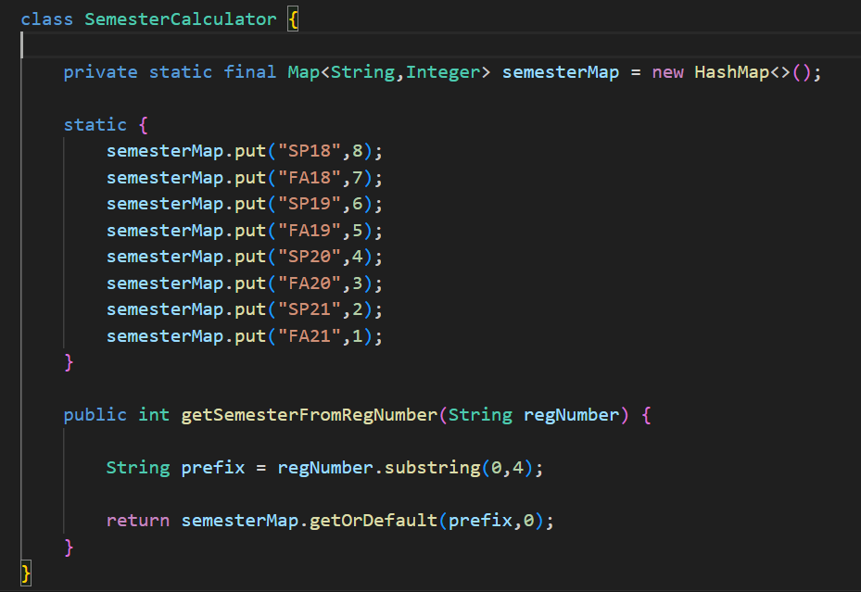
4. Primitive Obsession
Primitive Obsession means:
Using primitive types (String, int, arrays) to represent complex domain concepts instead of creating proper domain objects.
Location of primitive obsession occurrence : (String course line, String[] courseDetails, split(","))
Courses are treated as raw strings instead of a Course object.
Previous Code:
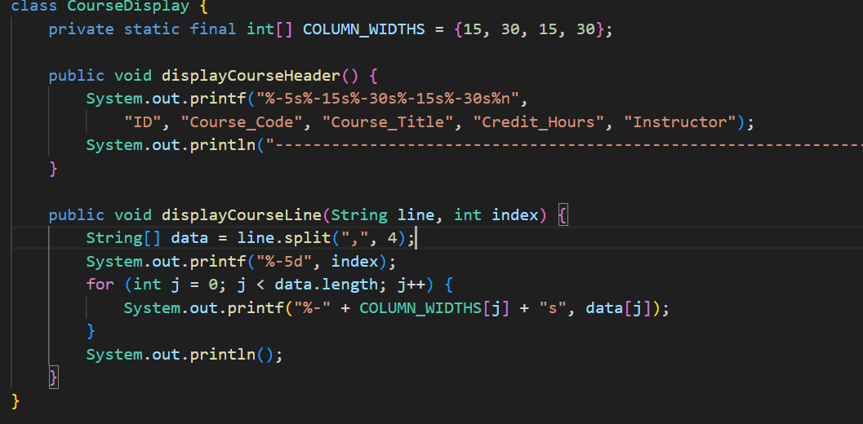
………………………………………………………………………………………..
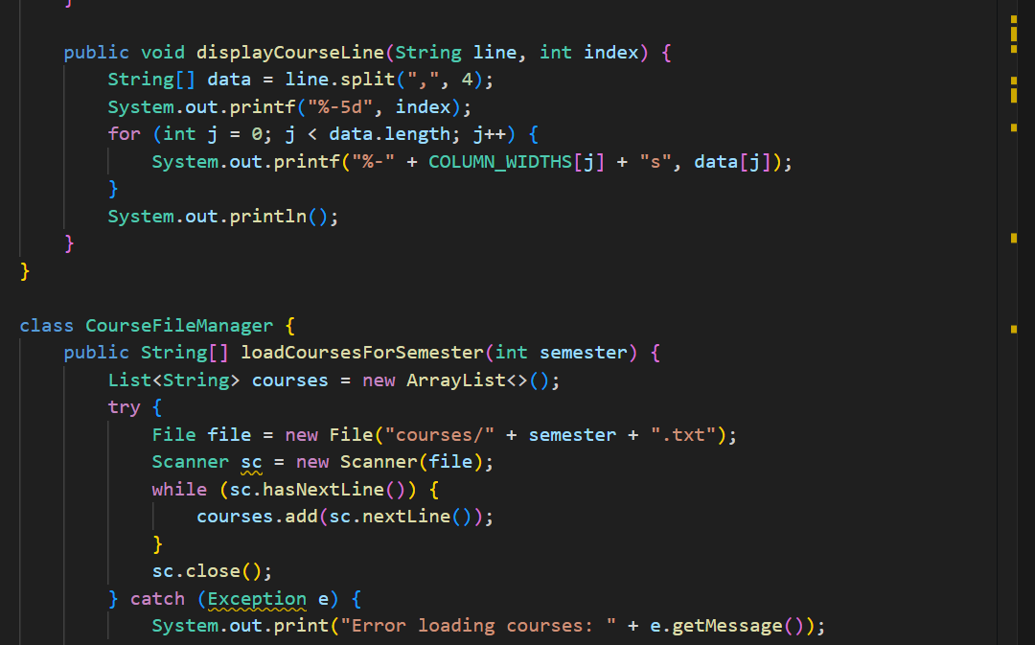
………………………………………………………………………………………
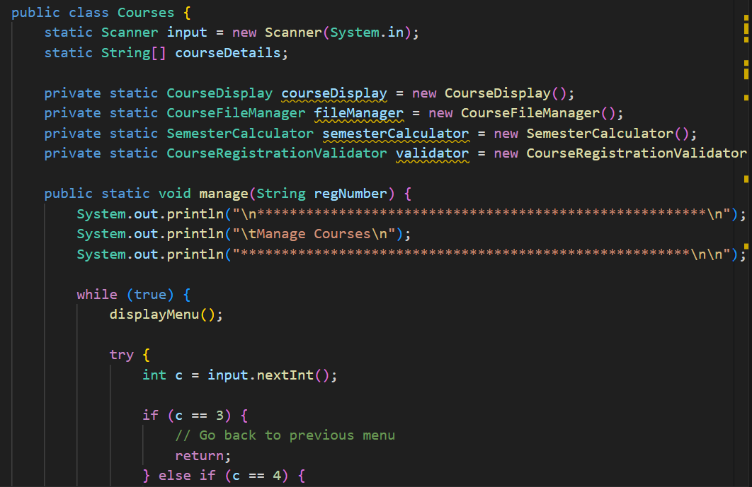
……………………………………………………………………………………..
Refactoring:
Remedy Used: Extract Class
Instead of handling raw strings everywhere, we have introduced Course class
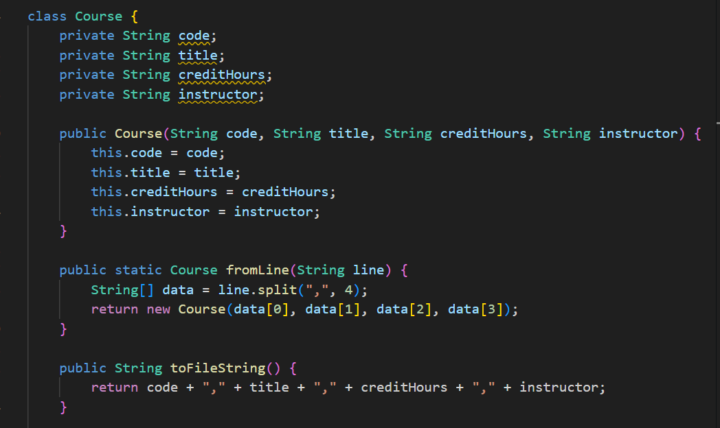
………………………………………………………………………………….
For CoursesRegistration.java:
- Long Parameter List
Previous Code:
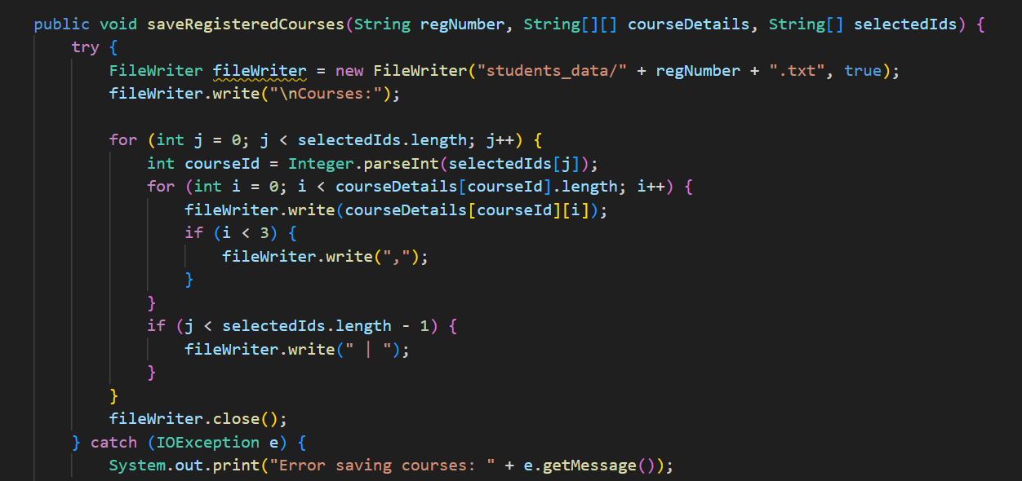
…………………………………………………………………………………………………………………………………….
Passing raw arrays is not ideal.
Refactoring:
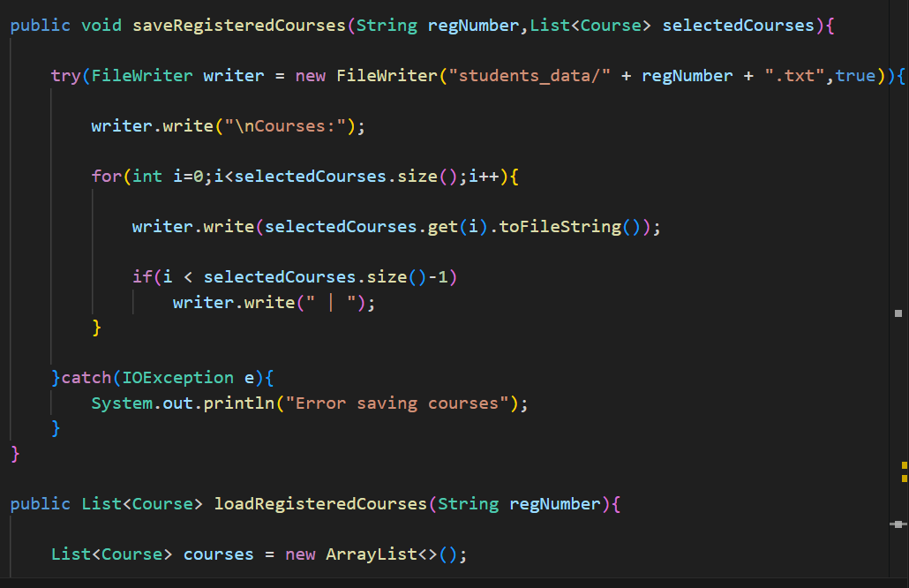
………………………………………………………………………………………………………………………………………….
2. Duplicate code
Inside RegistrationFileManager has saveRegisteredCourses().Again inside CourseRegistration.manage()has :
[FileWriter fileWriter = new FileWriter("students_data/" + regNumber + ".txt", true);
fileWriter.write("\nCourses:");]

Previous Code:
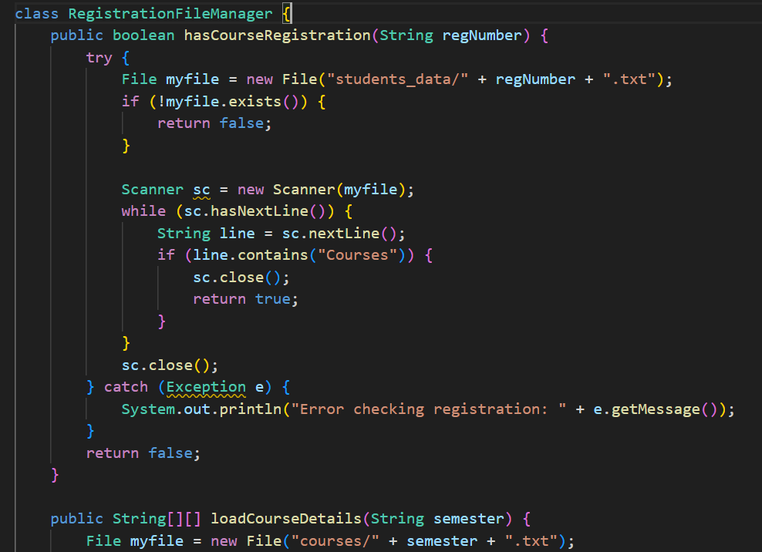
……………………………………………………………………………………..
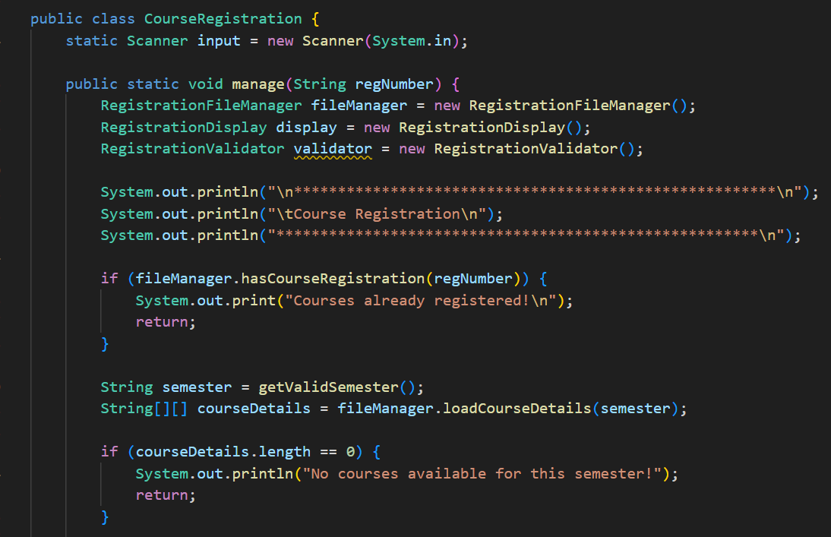
………………………………………………………………………………………..
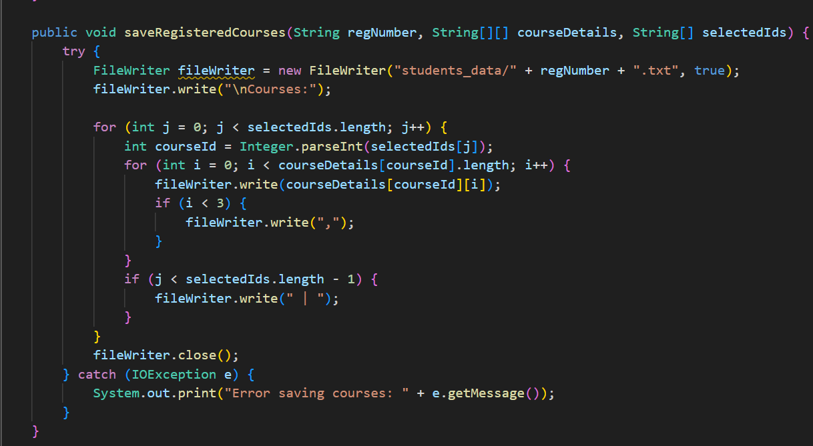
…………………………………………………………………………………………….
Refactoring:
Solved it in a single method.
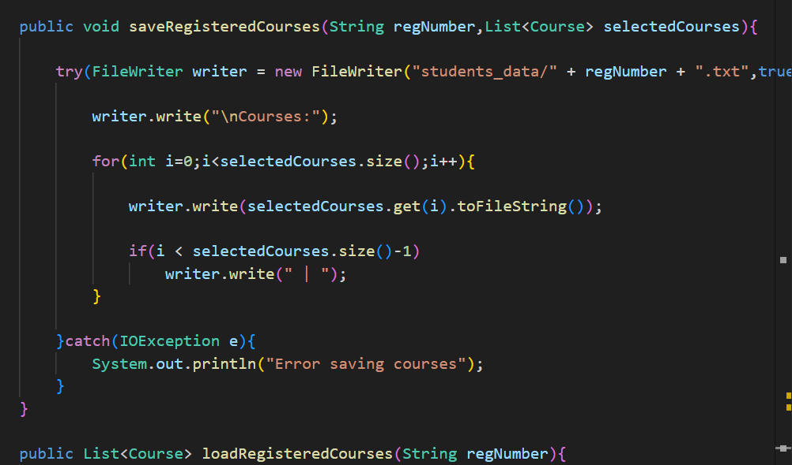

3. Long Method
In the class CourseRegistration manage method is very long and performs multiple responsibilities:
- Gets valid semester
- Loads course data
- Displays registered courses
- Gets selected IDs
- Writes courses to file
- Checks registration
Previous Code:
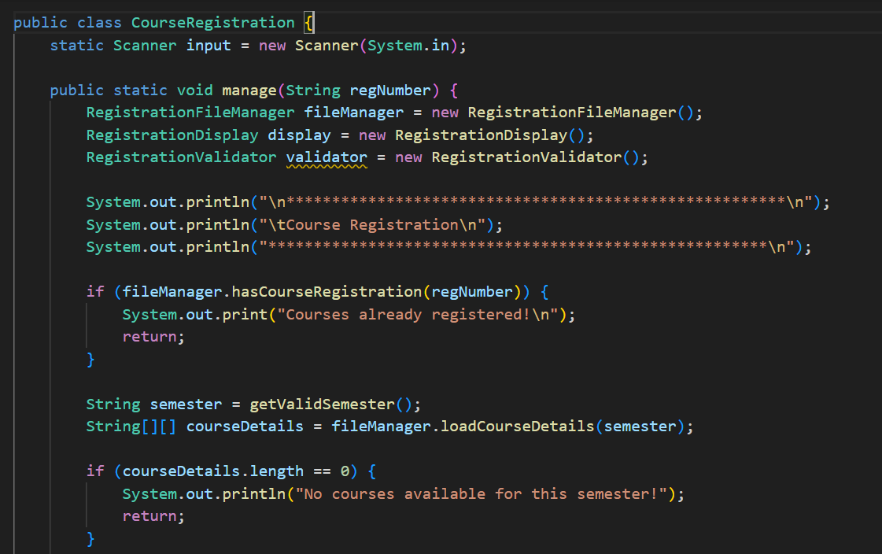
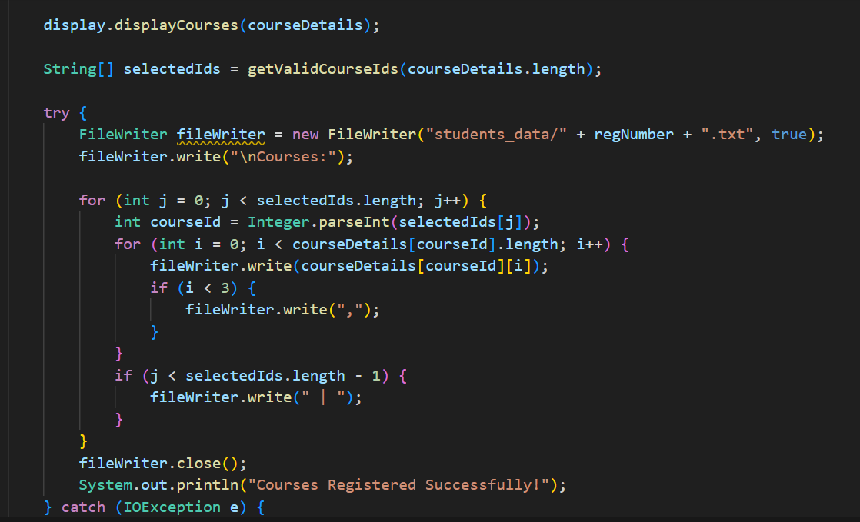
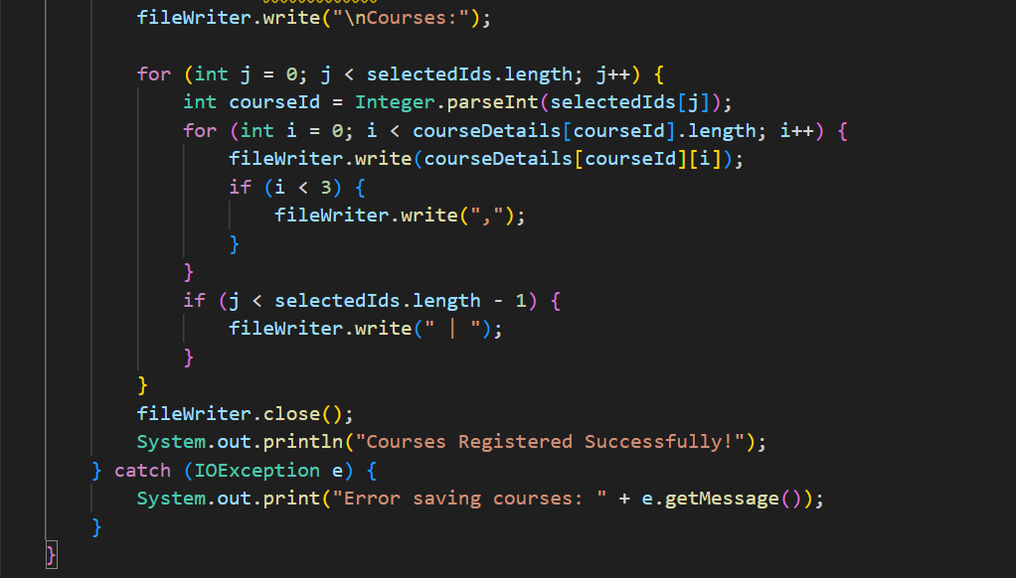
Refactoring:
Remedy Used: Extract Method
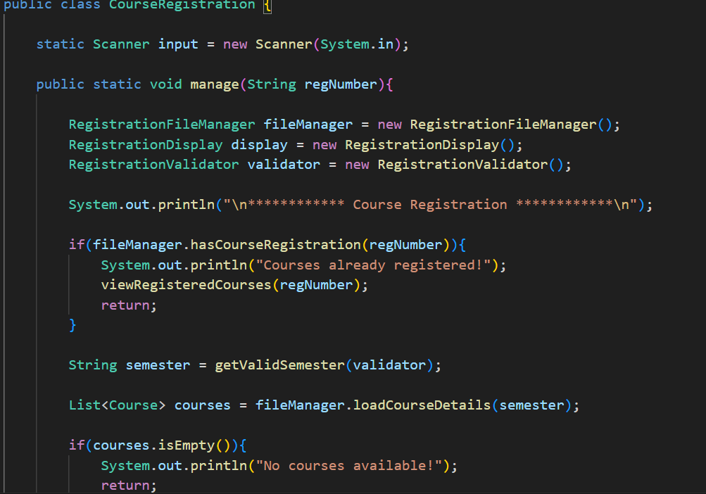
………………………………………………………………………………………………
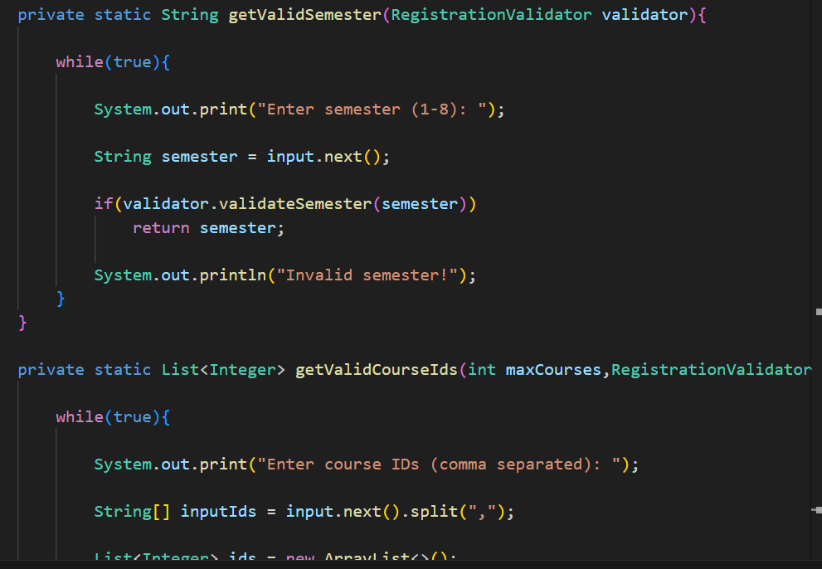
………………………………………………………………………………………………..
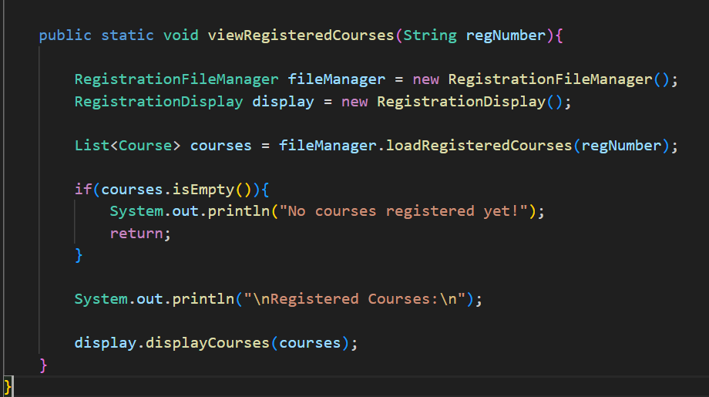
4. Primitive obsession
We have used primitive arrays for course information:
String[][] courseDetails
Courses are structured data but treated as raw arrays. This is Primitive Obsession because raw arrays are used instead of a proper class.
Previous Code:
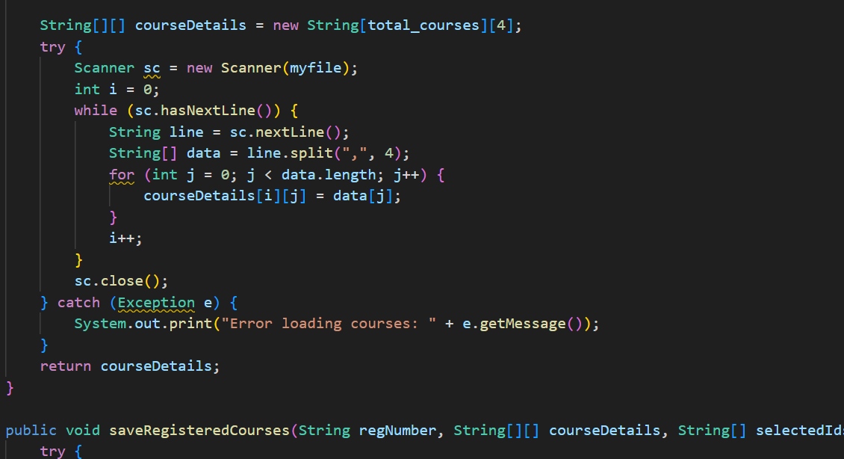

Remedy used: Replace Array with Object
I replaced the array with a Course object.
Now courses are stored as list.
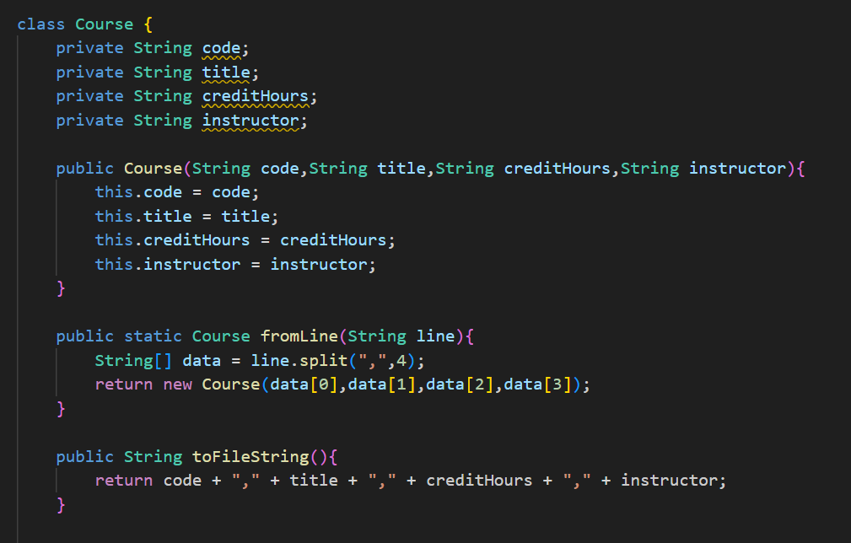
………………………………………………………………………………………….
Output after refactoring:
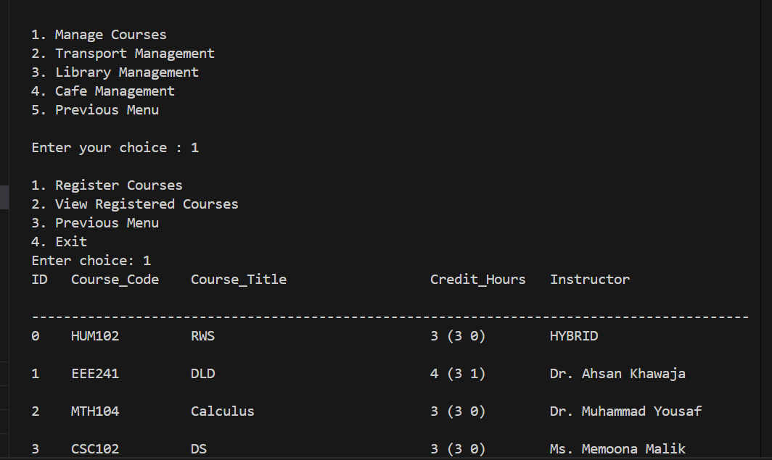
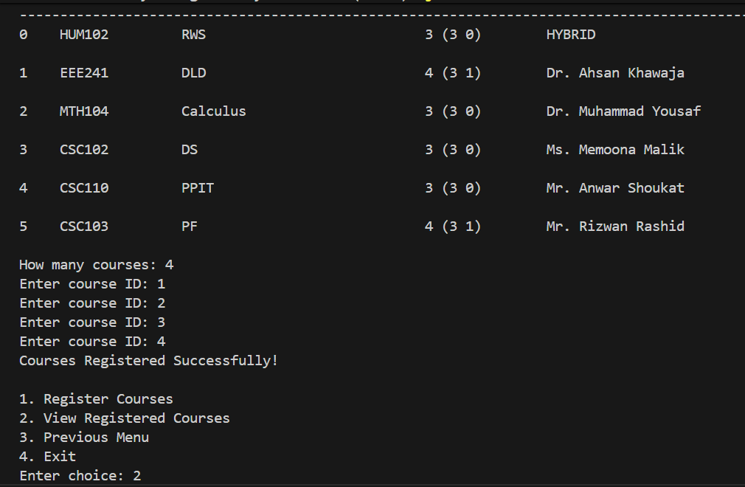
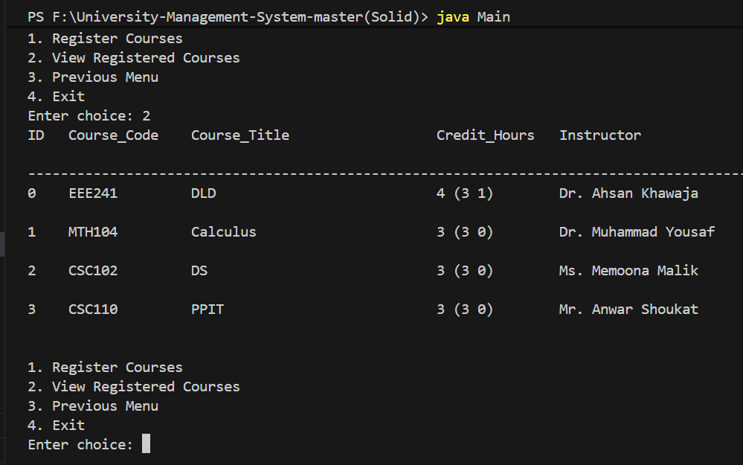

Design Pattern
Applied Design Pattern: Creational Design Pattern
For Courses.java:
Applied Method: Singleton Pattern
Singleton is a creational design pattern that lets you ensure that a class has only one
Instance, while providing a global access point to this instance.
Previous Code:
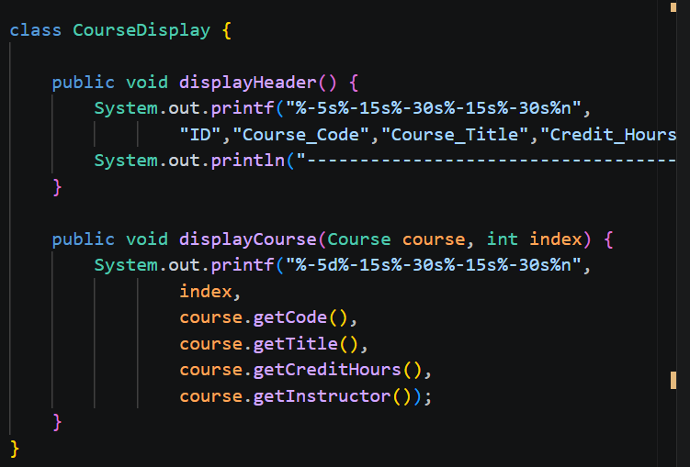
………………………………………………………………………………………………………………………………………………
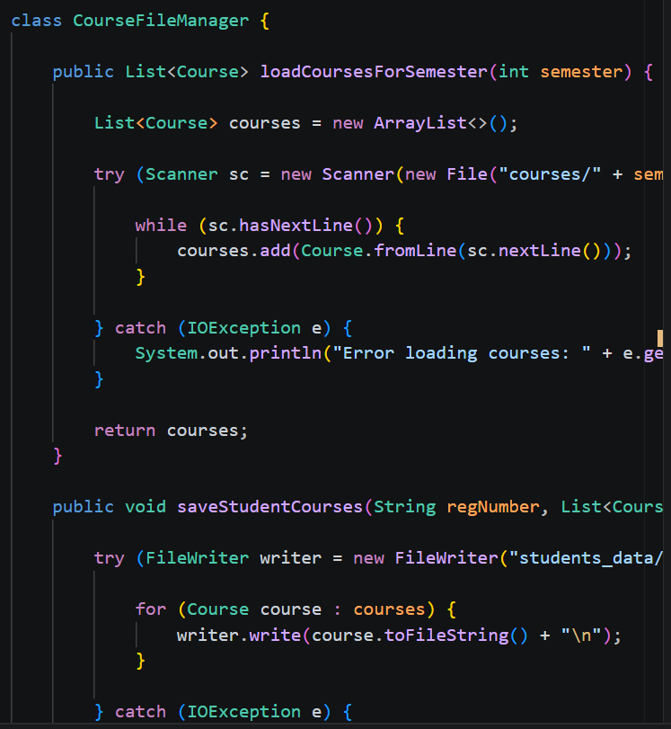
…………………………………………………………………………………………………………………………………………
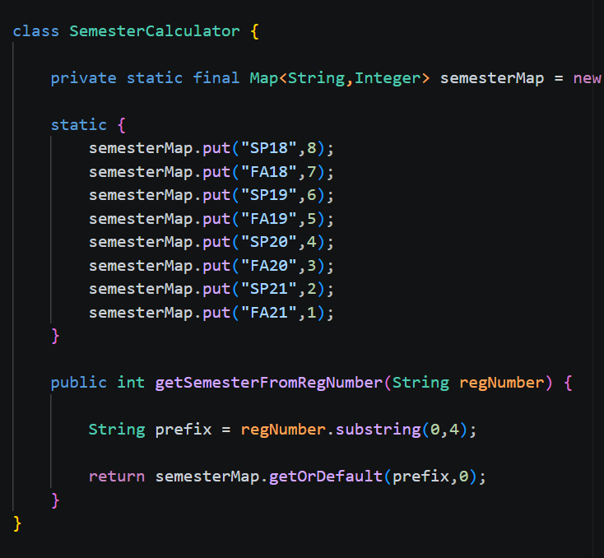
…………………………………………………………………………………………………………………………………………
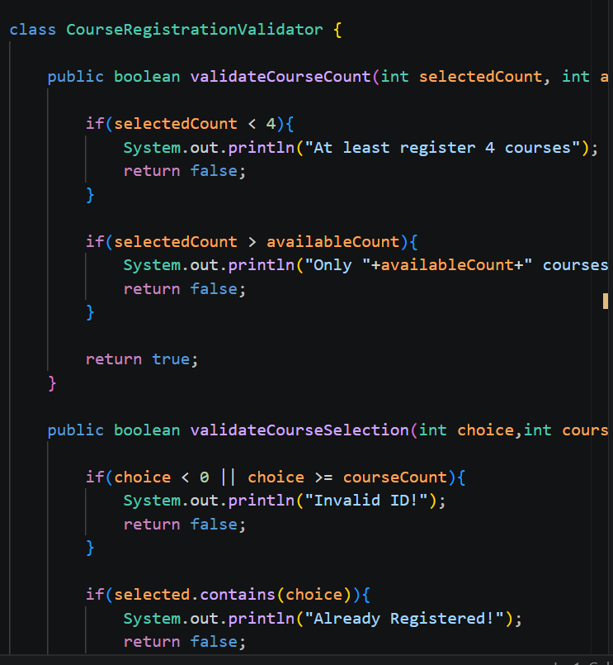
…………………………………………………………………………………………………………………………………………

After Applying Singleton Pattern:
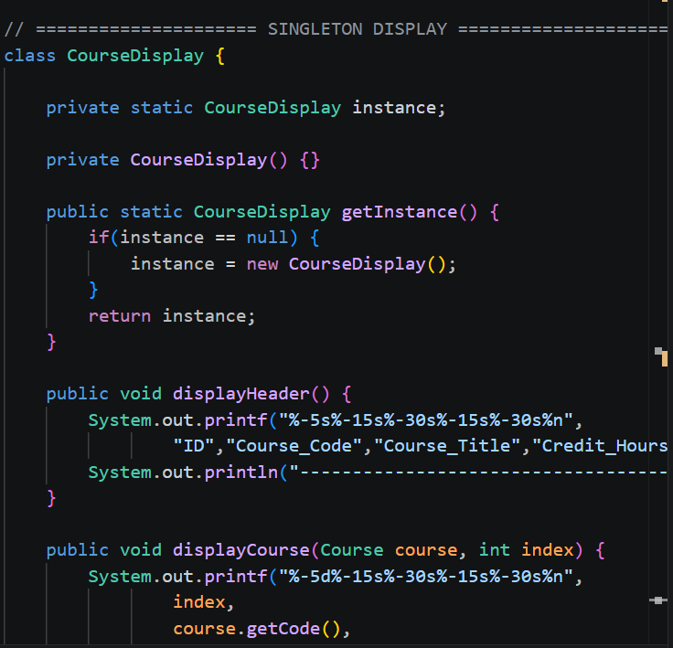
………………………………………………………………………………………………………………………………………..
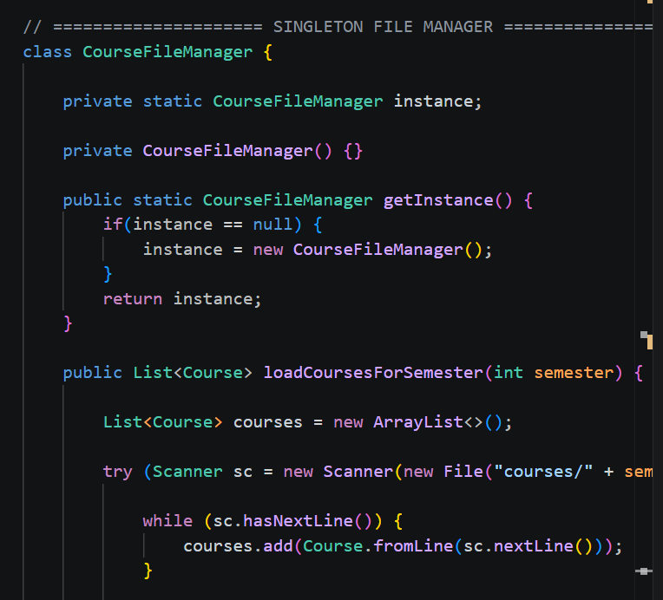
………………………………………………………………………………………………………………………………………..
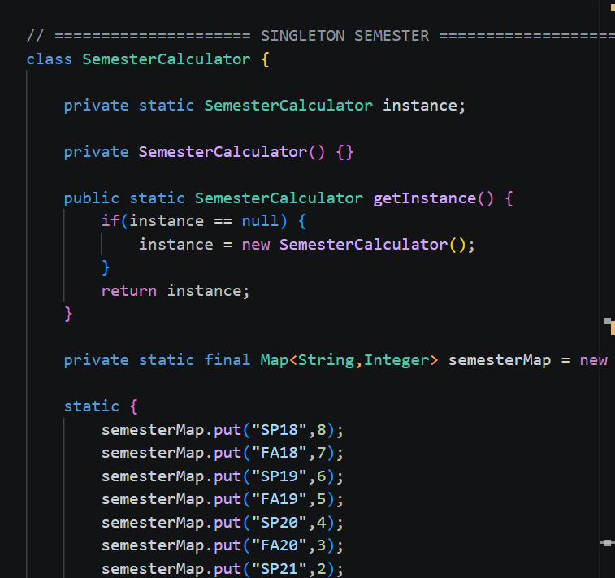
………………………………………………………………………………………………………………………………………..
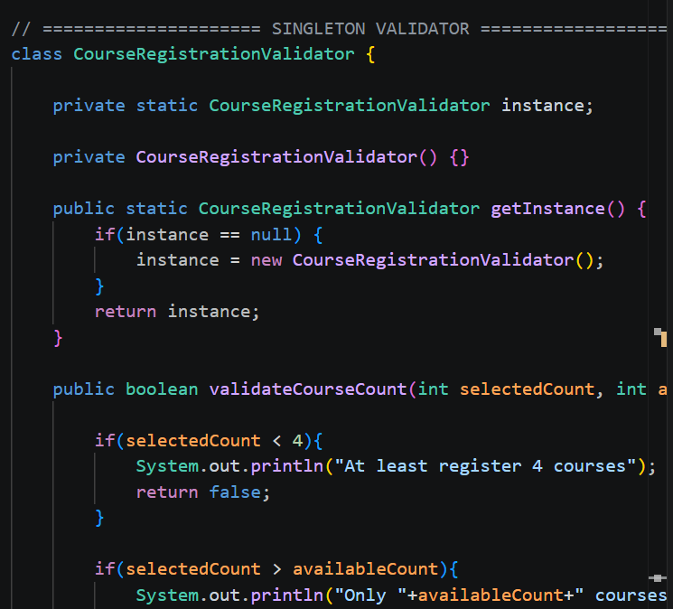
………………………………………………………………………………………………………………………………………..

For CoursesRegistration.java:
Applied Method: Singleton Pattern
Singleton is a creational design pattern that lets you ensure that a class has only one
Instance, while providing a global access point to this instance.
Previous Code:
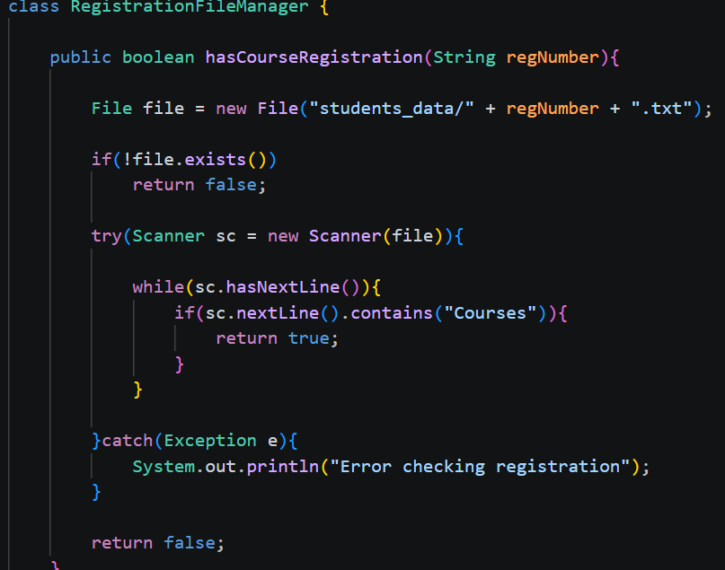
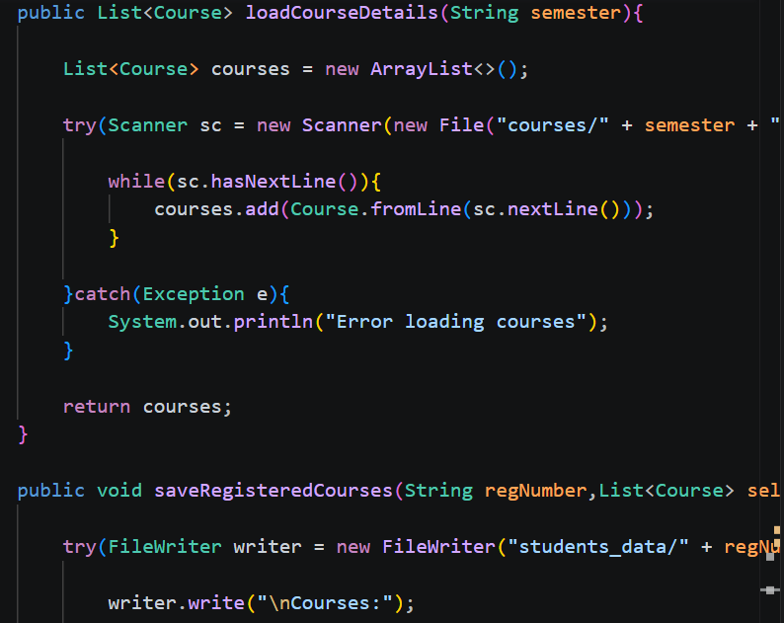
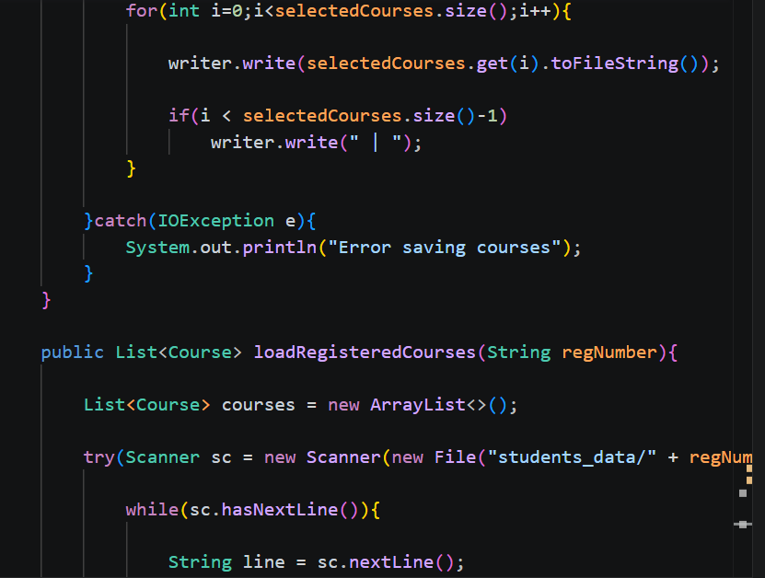
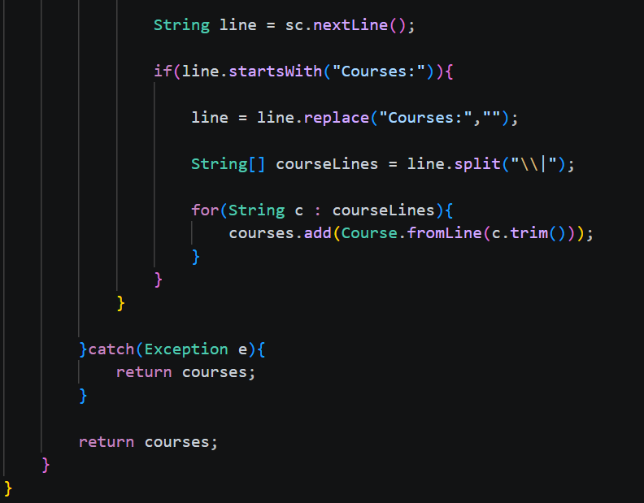
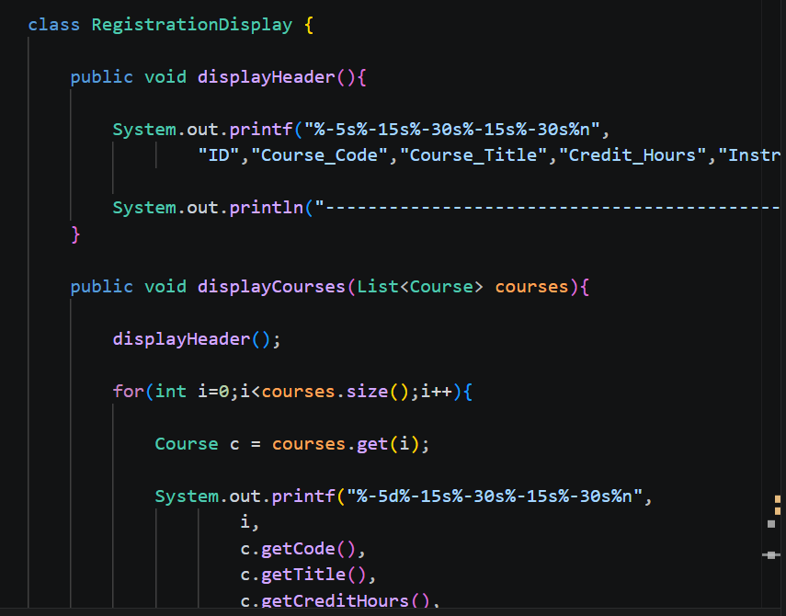
………………………………………………………………………………………………………………………………………..
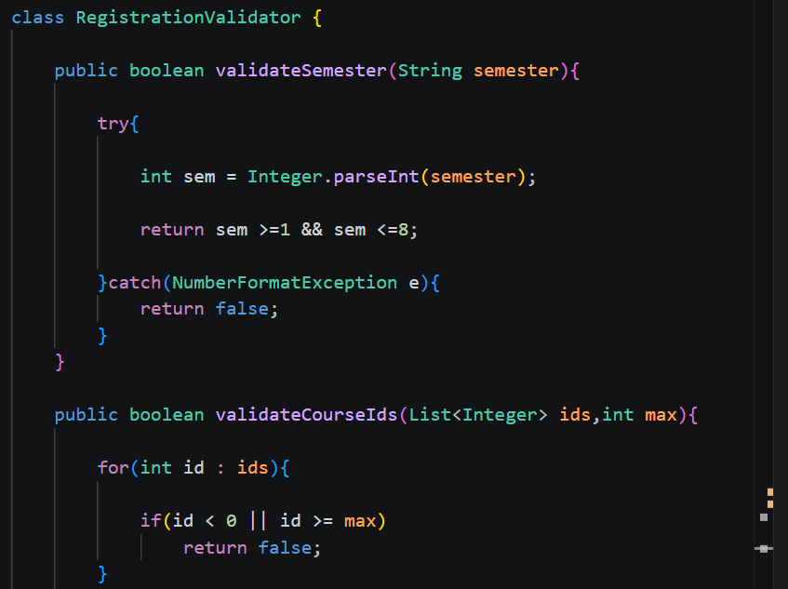
………………………………………………………………………………………………………………………………………..
After Applying Singleton Pattern:
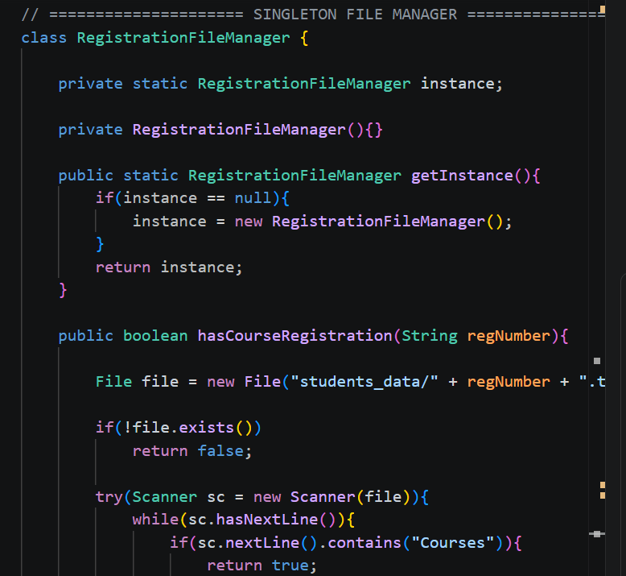
……………………………………………………………………………………………………………………………………………
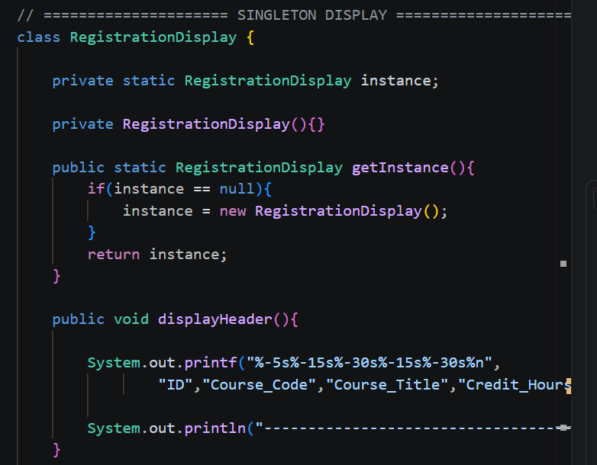
………………………………………………………………………………………………………………………………………
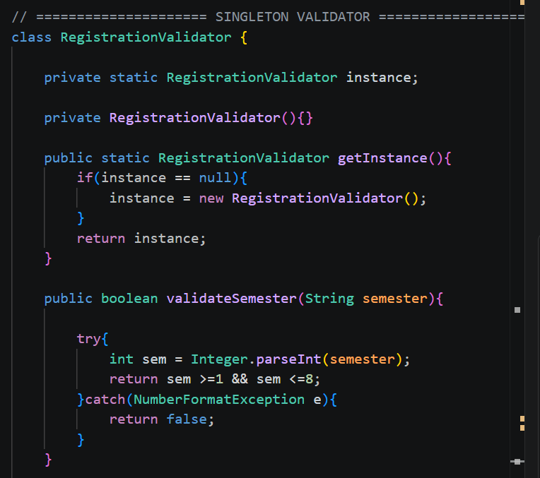
………………………………………………………………………………………………………………………………………
Output:

